**DDCO Project**

# **Team Members:**

* Nikhil Girish / PES2UG21CS334
* P Niveditha / PES2UG21CS355
* P Sai Charan / PES2UG21CS364
* Onkar Suhasrao Pampattiwar / PES2UG21CS353

# **Implementing Left Shift and Right Shift operations for existing register array**

## **Code:**

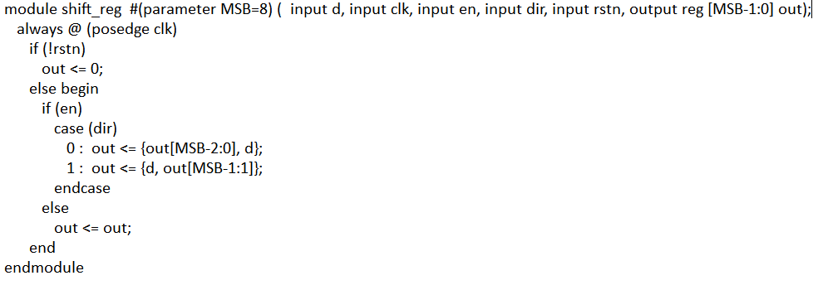

Testbench file:

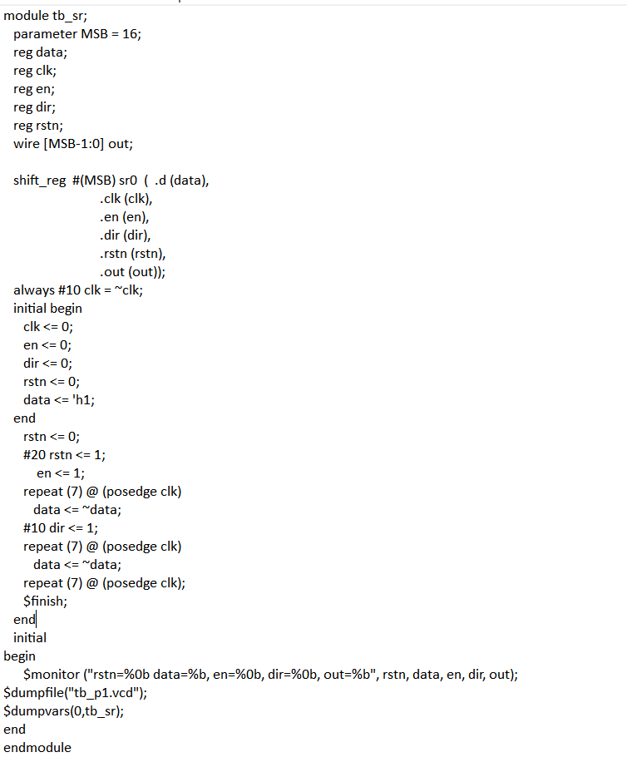

CMD:

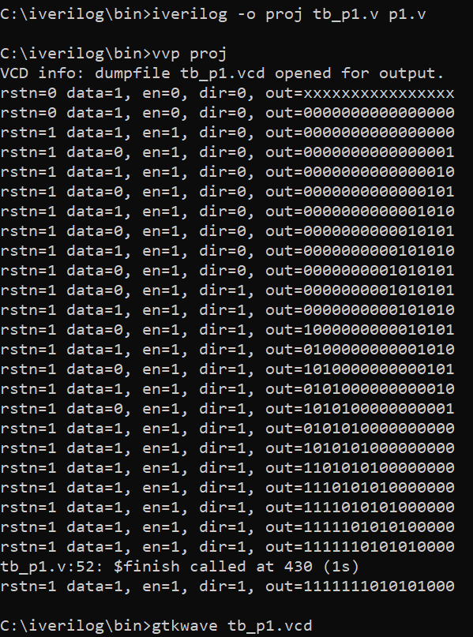

GTKWAVE:

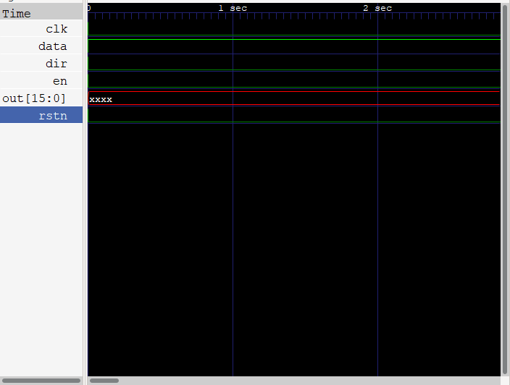

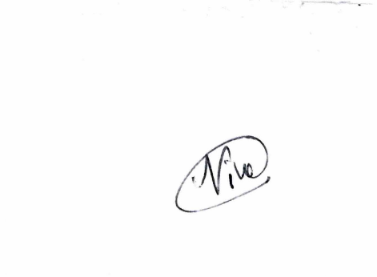

# **Signatures:**

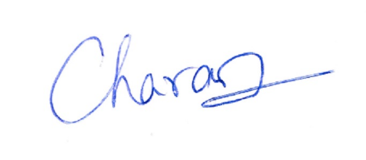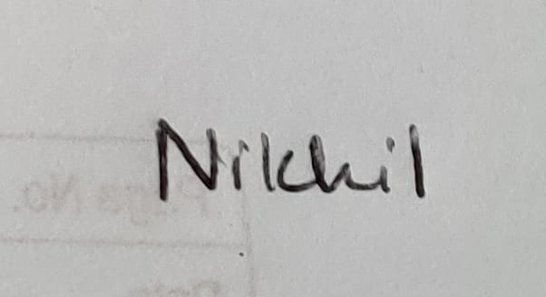

Nikhil Girish P Niveditha P Sai Charan

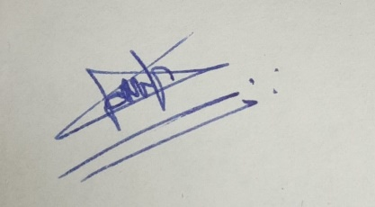

Onkar Suhasrao Pampattiwar